Supplementary Figure 1

A) Target Species in NCBI database
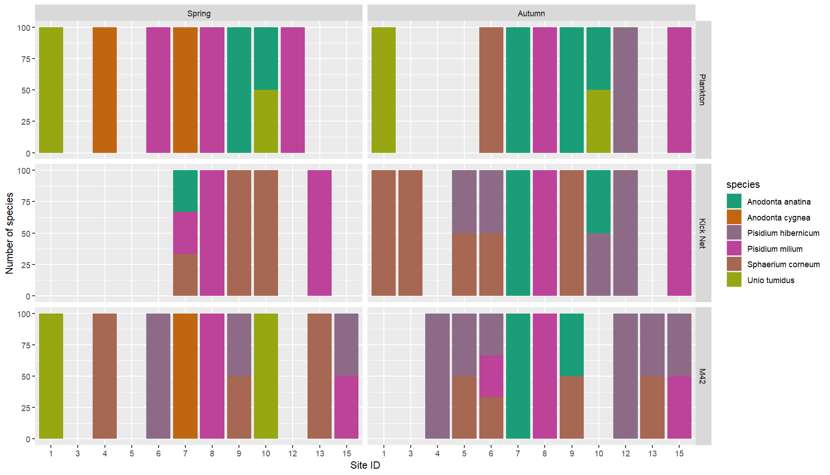
Total: 6 species

B) Target Species found in BOLD database
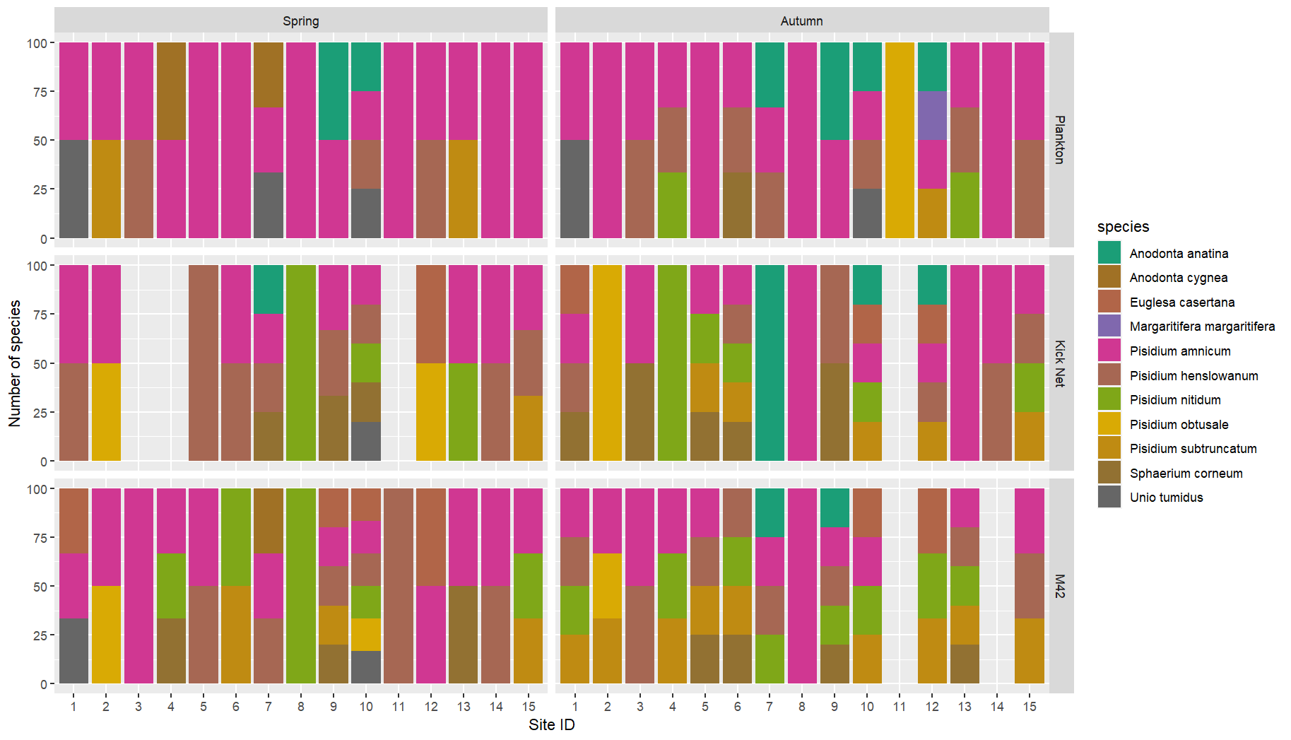
Total: 11 species

C) All phyla searched in NCBI and BOLD
